iiNews

***A simple news app, no adds and unnecessary functions, only news.***

### ***By Delil Demirsoy***

**Development case description**

How often do you check the news per day? 1, 2 or 5 times a day? Or maybe more? News has taken over too much of our lives and time. News are everywhere, it’s in our TV’s, computers and cell phones. Often we do not realize when we read too much news, we simply do not know when it is too much. There are many news apps available out there. However, there is some issues with these apps. The goal with such app should be to publish news but that's not the case for many websites and apps nowadays. When you visit websites like Aftonbladet, CNN or BBC news, the news too complicated to read. Sometimes it is too long explanation and in some cases the adds bothers you when you are trying to read an article on the news page. That is waste of time for those who only wants to keep themselves updated and get fast news without getting bothered with unnecessary buttons and adds.The goal with this project was to make a news app that do not waste time but still works effectively.

**User stories**

In this project user case stories were used. The user case stories can be useful to illustrate how a user will accomplish a specific goal on a website or an app. The user stories down below illustrates what goal actors wants to achieve.

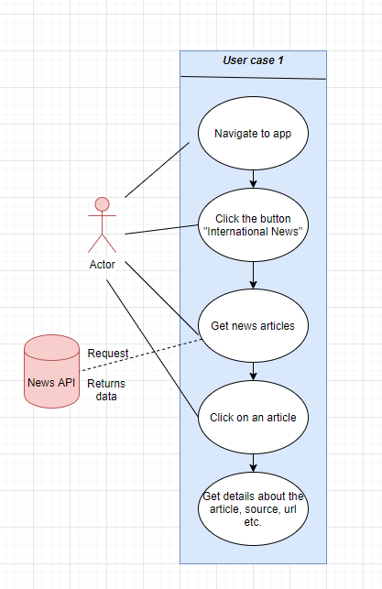

***Figure 1:*** The actor navigates to the app and clicks the button “International News”. After he has done that, news articles pups up on the screen from the API. The actor click on one specific article, he then gets a brief description about that article and source url to the website.

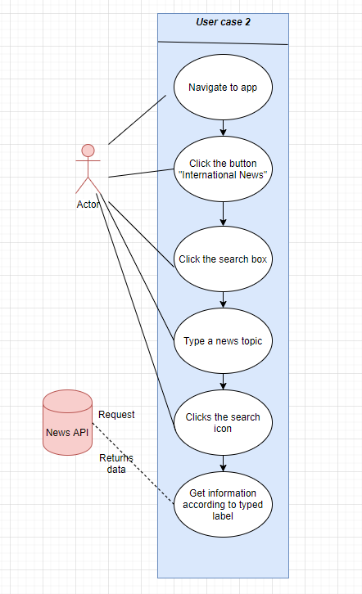

***Figure 2:*** The second user case illustrates when the actor clicks the “Search box” to search a specific article. After he clicks the search box, he types a news topic and later on when he has clicked the search icon, he gets news according to what he has written on the search box.

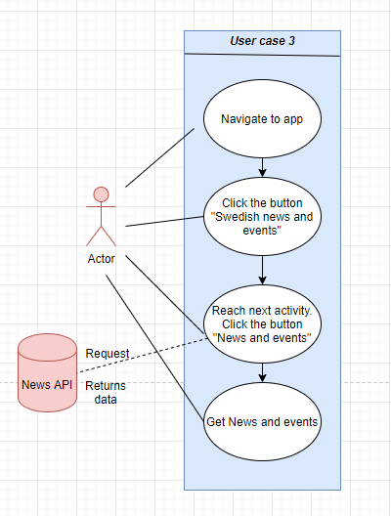

***Figure 3:*** Here the actor navigates to the app and then clicks the “Swedish news and events” button. Later on, the actor reaches the next window where he clicks the button “News and events”. After the button is clicked, it takes around two second until he gets the latest news and events from Sweden.

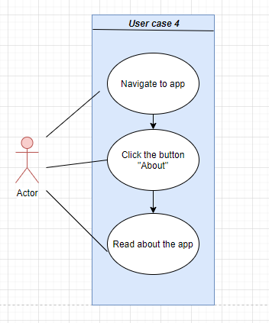

***Figure 4:*** The fourth and last user case illustrates how the actor goes to the “About” page through clicking the button “About” in the first place.

**How will the users benefit from this app?**

***iiNews*** was developed for only one purpose, to give users a better experience without wasting their time when they are reading news. In the app the user has two main simple options, the first button leads you to the “International news” section, where you see the top news with a short title. If the user wishes to get more details about a specific article, they can read more about it through clicking on the article. Simple as that. When it is clicked, users will see more details about that article, they will even get an url of the source of the article just beneath the description. In that way, users can dig deeper and read more about the article if they want to do so. The goal is to keep the users updated in a fast and easy way through having self explaining titles. A search function is also available in the app for those who wants to find a specific topic. Those who do not want to waste hours on the news sites will benefit from this app, because it is simple, easy and very effective to use as you can see above in user cases.

The second main option takes the user to the “Swedish news and events” section. This section was developed especially for those who lives in sweden. The api that was used is an api of the police department in Sweden. Everytime an accident or crime event occurs, for instance a car accident or a bank robbery, the police will put that information online and through the api we can publish this information on the app. When an event is published, we get a simple summary of what has happened, where the accident occurred and the exact date and time. The ones that could benefit from this special section would be car drivers in Sweden. Let’s suppose that you are planning to drive to Gothenburg from E45 highway, suddenly an accident occurs on that highway that you would have driven from. You could benefit from using ***iiNews*** in this case, because you would save time and would not need to waste gasoline which in turn would lead to *unnecessary nature pollution.*

**Technical Features**

In the ***iiNews*** application***,*** to get all the news articles an API (Application programming interfaces) was used. The API that was used has a huge range of publishers, around 30.000 worldwide sources. The API that was found called "News Api” is a simple and easy-to-use API. It returns JSON metadata for all articles and headlines that is currently live on internet right this moment. It is very fast and asynchronously cached for a fast and effective response. The fact that it is free for the developers makes it easier to use. Another advantage with this feature is that it is easy to integrate, you can simply get JSON result through simple get HTTP request (News API, n.d). However, no web service connections, sensors, camera nor databases was used in ***iiNews*** application.

**Flow chart**

A flow chart is a graphical description of an algorithm or process. It is graphic structure may consist of ovals, rectangles, and rhombuses bound together by arrows to show the order in the flow chart, downbelow the flow chart of the app is illustrated

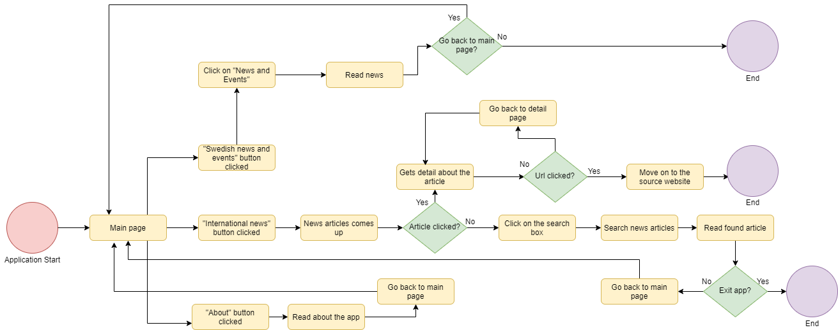

***Figure 5:*** Application starts, user comes to main page and has three buttons to choose between. The button “International news” is clicked, the user now sees all the news articles. If a specific article is clicked, it takes the user to detail page and now the user can read details about the article. If the article is not clicked, the users clicks on the search box to search news and articles. Later on the user reads the article that is found. If the user decides to exit the app the task ends, if not, the users goes back to the main page.

The “Swedish news and events” button is clicked, the user then click on “News and events” button in the next page. The news article pops up and the user reads it. If the user decides not to go back to main page, the task ends, otherwise the users goes back to main page.

The “About button” is clicked, the user comes to the About page where he reads information about the app. Then the users goes back to main page.

**Why have you chosen a particular navigation pattern?**

Navigation pattern plays a big roll in how users interact with the application and use the product. Navigation pattern shows the users how they can get from point A to B and even point C. The ***iiNews*** application has easy design patterns, when the users open the application they have only three simple buttons to choose between which takes them to next activity. The reason why this particular navigation pattern was choosedis due to make the use of the app easier and effective. The patterns that are available in the application provide relevant information to the user which makes it simple to use. Compare to other apps ***iiNews***, does not contain unnecessary functions and buttons. This gives many benefits to the users, the users no longer needs to think about buttons that does not fulfill any requirement.

Many news apps has numbers of functions and buttons with no relevant meaning, some users may get confused by that. It may depend on their age or other factors. ***iiNews*** does not contain such functions which makes it easy to navigate between activities for most of the users.

**Graphic design**

This is the splash screen of the app. The reason why this background color was used is because of the name of the app. iiNews stands for international important news, in the app we get news around the world, therefore the picture is relevant and was used for that reason. The red color was used for the text because it gives us the sense of importance and notifies us about a danger as well.

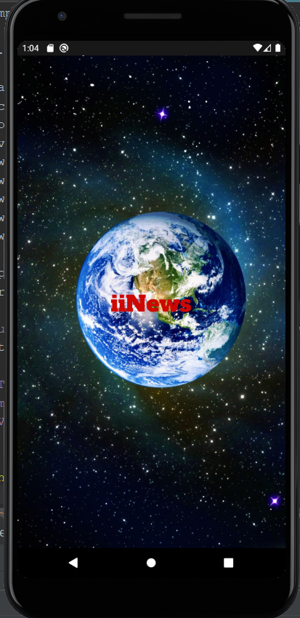

***Figure 6***: This is the page the users see when the application starts. The background picture was used to give the user a good feeling, its a view that makes the application more user friendly.

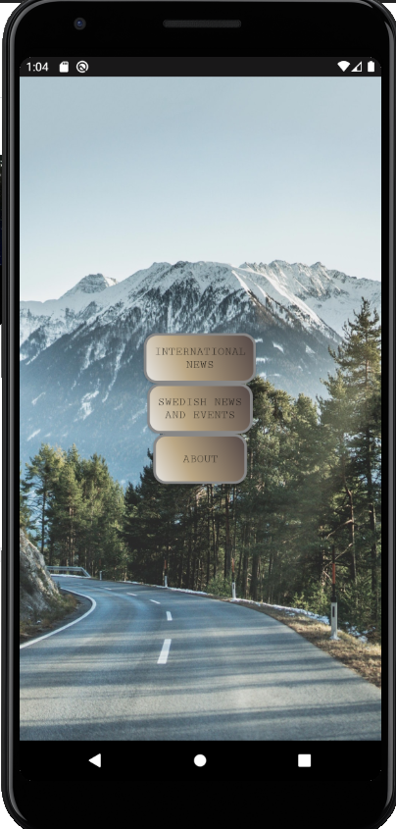

***Figure 7:*** Shows the color of the buttons were chosen because it suits the background image and looks beautiful.

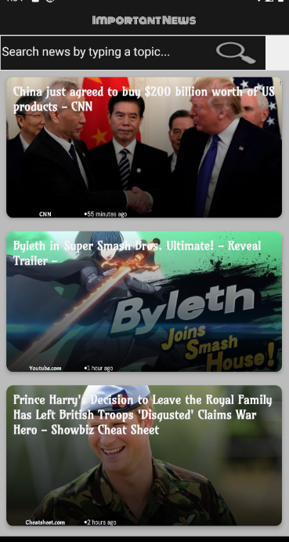

***Figure 8***: Shows all the news articles. The color that were used are grey, black and white. At the top the white text is used in the text view, the reason for that is because it looks beautiful and user friendly. Same colors were used in figure 9 downbelow for same reasons.

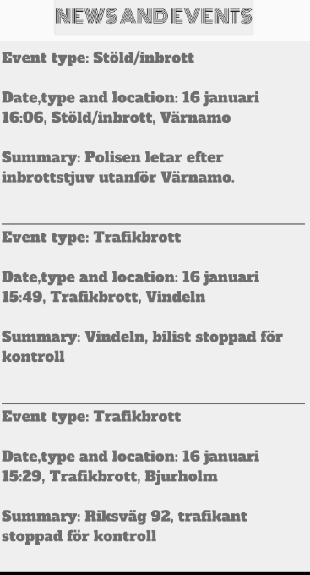

***Figure 9***

**Code description**

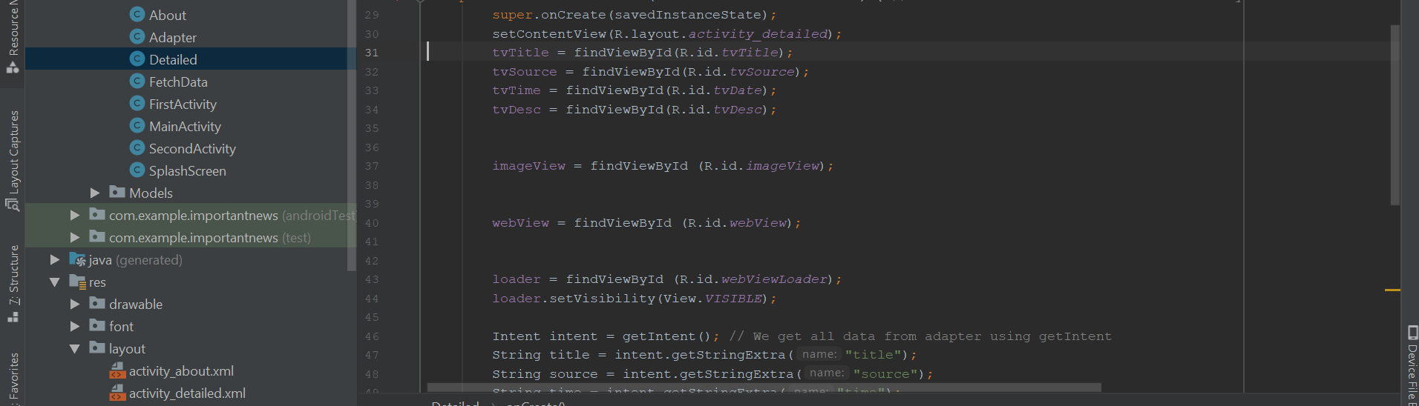

**Figure 10:** This is a code snippet from the Detailed class, some parts of the code from this class was inspired from a youtube tutorial (link is available at MainPage class). findViewById() is used to find a view in the layout of our activity. I had trouble to do that before I watched the tutorial, for some reason, I could not show details about the article. After spending hours to find the problem, I finally found the tutorial that could give me a good understanding of the code.

The ImageView object is used to display image resources, it is commonly used to apply tints to a picture. The webView object allows us to show web content as part our activity, we can say that it is a view that displays web pages.

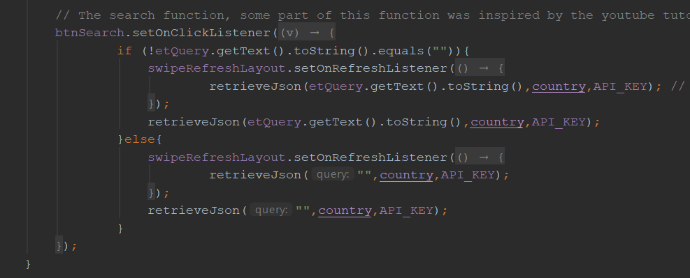

**Figure 11:** Shows the search function that was inspired from the youtube tutorial. At first, I made a function that was similar to this one above, but for some reason it did not want to work, so I instead used the tutorial as help.

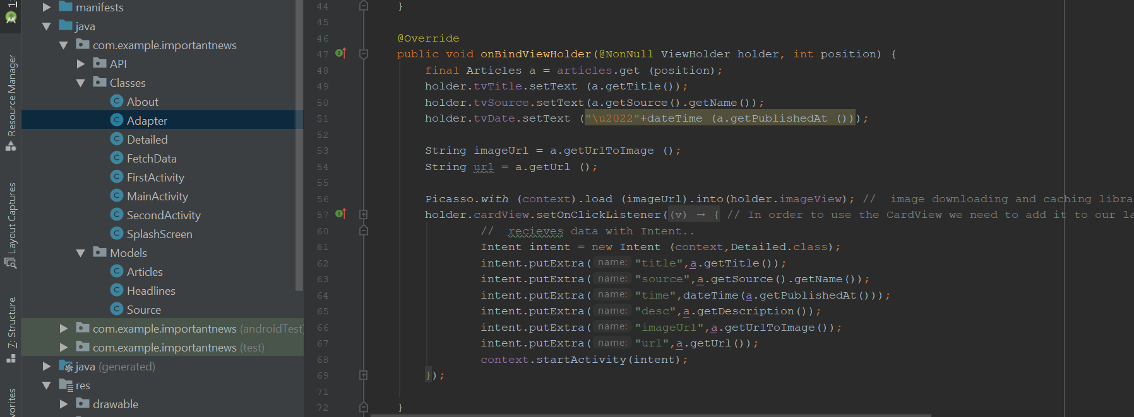

**Figure 12:** Shows the Adapter class, the Picasso plugin was used to download images, the cardview was also used in order to show information inside cards that has a consistent look. The intent abstract is used to show data with Intent. These are also parts that was inspired from the tutorial.